**Exercise 1: Logging Error Messages and Warning Levels**

**Logging Error Messages and Warning Levels Task:**

**Write a Java application that demonstrates logging error messages and warning levels using SLF4J.**

**Step-by-Step Solution:**

1. **Add SLF4J and Logback dependencies to your `pom.xml` file: org.slf4j slf4j-api 1.7.30 ch.qos.logback logback-classic 1.2.3 2. Create a Java class that uses SLF4J for logging:**

**import org.slf4j.Logger; import org.slf4j.LoggerFactory;**

**public class LoggingExample {**

**private static final Logger logger = LoggerFactory.getLogger(LoggingExample.class);**

**public static void main(String[] args) {**

**logger.error("This is an error message");**

**logger.warn("This is a warning message");**

**}**

**}**

**CODE:**

**Loggingexample.java:**

package org.example;  
import org.slf4j.Logger;  
import org.slf4j.LoggerFactory;  
public class LoggingExample {  
 private static final Logger *logger* = LoggerFactory.*getLogger*(LoggingExample.class);  
 public static void main(String[] args) {  
 *logger*.error("This is an error message");  
 *logger*.warn("This is a warning message");  
 *logger*.info("This is an info message");  
 *logger*.debug("This is a debug message");  
 *logger*.trace("This is a trace message");  
 }  
}

**Logback.xml:**

<configuration>  
 <appender name="CONSOLE" class="ch.qos.logback.core.ConsoleAppender">  
 <encoder>  
 <pattern>%d{HH:mm:ss.SSS} [%thread] %-5level %logger{36} - %msg%n</pattern>  
 </encoder>  
 </appender>  
 <appender name="FILE" class="ch.qos.logback.core.FileAppender">  
 <file>logs/app.log</file>  
 <append>true</append>  
 <encoder>  
 <pattern>%d{yyyy-MM-dd HH:mm:ss} %-5level %logger{36} - %msg%n</pattern>  
 </encoder>  
 </appender>  
 <!-- Optional: JSON logs -->  
 <appender name="JSON-FILE" class="ch.qos.logback.core.FileAppender">  
 <file>logs/json-log.json</file>  
 <append>true</append>  
 <encoder class="net.logstash.logback.encoder.LogstashEncoder" />  
 </appender>  
 <root level="trace">  
 <appender-ref ref="CONSOLE" />  
 <appender-ref ref="FILE" />  
 <appender-ref ref="JSON-FILE" /> <!-- Only if JSON enabled -->  
 </root>  
</configuration>

**Pom.xml:**

<?xml version="1.0" encoding="UTF-8"?>  
<project xmlns="http://maven.apache.org/POM/4.0.0"  
 xmlns:xsi="http://www.w3.org/2001/XMLSchema-instance"  
 xsi:schemaLocation="http://maven.apache.org/POM/4.0.0 http://maven.apache.org/xsd/maven-4.0.0.xsd">  
 <modelVersion>4.0.0</modelVersion>  
 <groupId>org.example</groupId>  
 <artifactId>logging</artifactId>  
 <version>1.0-SNAPSHOT</version>  
 <dependencies>  
 <!-- SLF4J API -->  
 <dependency>  
 <groupId>org.slf4j</groupId>  
 <artifactId>slf4j-api</artifactId>  
 <version>1.7.30</version>  
 </dependency>  
  
 <!-- Logback (SLF4J implementation) -->  
 <dependency>  
 <groupId>ch.qos.logback</groupId>  
 <artifactId>logback-classic</artifactId>  
 <version>1.2.3</version>  
 </dependency>  
 <!-- Optional: JSON Logging Encoder -->  
 <dependency>  
 <groupId>net.logstash.logback</groupId>  
 <artifactId>logstash-logback-encoder</artifactId>  
 <version>7.4</version>  
 </dependency>  
 </dependencies>  
 <properties>  
 <maven.compiler.source>21</maven.compiler.source>  
 <maven.compiler.target>21</maven.compiler.target>  
 <project.build.sourceEncoding>UTF-8</project.build.sourceEncoding>  
 </properties>  
</project>

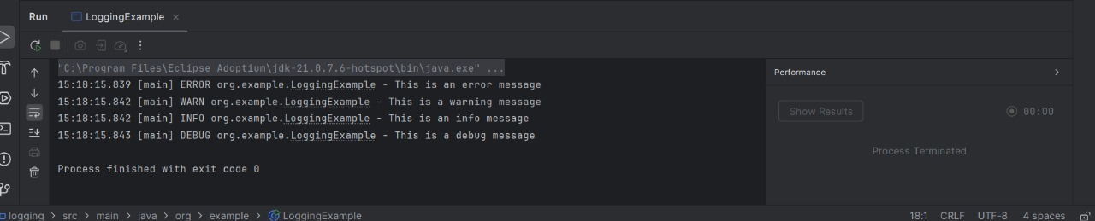**OUTPUT:**